**Dispatcher Middleware Description**

1. **About DispatcherMW**

This name of this application is DispatcherMW. DispatcherMW supplies online Machine Translation Service, which could translate xlf file.

1. **Application Dependency**
2. Maven: This project depends on Maven.
3. Install Third Part Library: Some library doesn’t exist in maven repository, so we need install them manually, see details in {lib}\__Install.txt.
4. About using code, the related GlobalSight MT Java code comes from “GlobalSight_8_5_3_Released_Branch”.
5. Eclipse configuration

* Install Eclipse Maven Plugin
* Configure Maven Repository

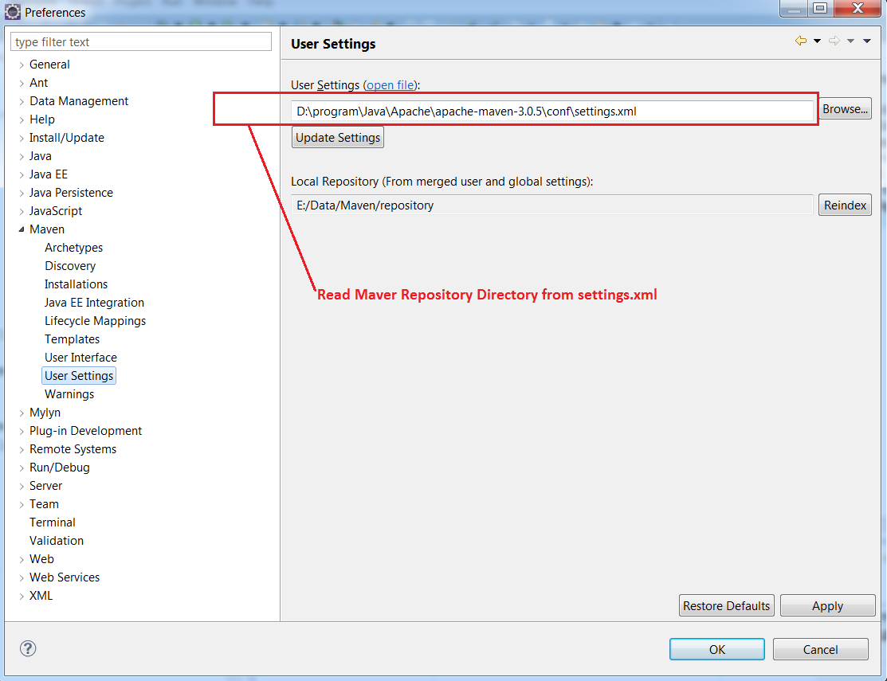

* Configure Project(Adds “M2_REPO” Variable in Project)

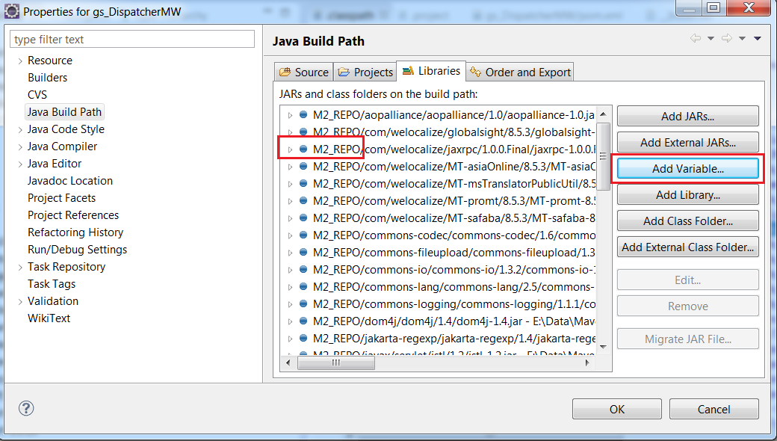

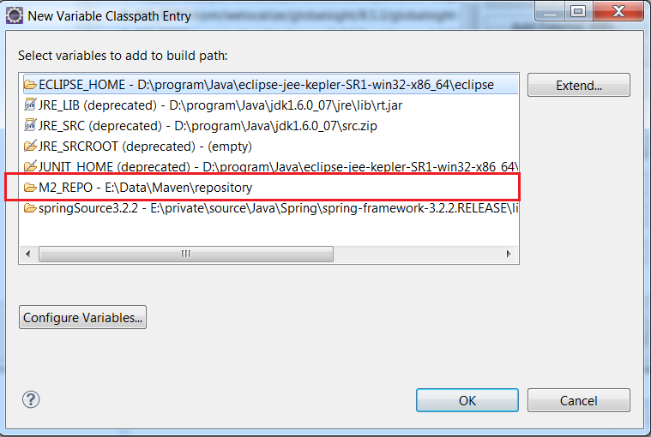

1. **Application Structures**

|-- pom.xml Maven POM File

|-- lib Third Part Library folder

|-- client DispatcherMW Client Code

|-- Document Project description folder

`-- src Java File

`-- main

|-- java DispatcherMW Java Files

|-- globalsight GlobalSight MT Java Files

|-- resources Include property file

`-- webapp

|-- WEB-INF

| |-- pages JSP Folder

| `-- web.xml

`-- resources

|-- css

|-- images

|-- jquery

`-- js

1. **Server Configuration**

The DispatcherMW Server needs some configuration:

1. Modify Encoding to support special character.

In Tomcat 7, modification file is {Server Path}/conf/server.xml,

And the related server parameter is

<Connector port="8888" protocol="HTTP/1.1" ="20000" redirectPort="8443" URIEncoding="UTF-8"/>

1. **Data save path**

The basic path is {Server Path}/DispatcherMW.

The sub files of DispatcherMW folder are:

|  |  |
| --- | --- |
| **Data Type** | **File Path** |
| MT Profile Info | DispatcherMW/data/MachineTranslationProfiles.xml |
| Account Info | DispatcherMW/data/Account.xml |
| Language Info | DispatcherMW/data/Languages.xml |
| Uploaded XLF file | DispatcherMW/fileStorage/{AccountName}/{Job ID}/source/*.xlf |
| Translated XLF file | DispatcherMW/fileStorage/{AccountName}/{Job ID}/target/*.xlf |

***Appendix:***

1. Maven command:

mvn version

mvn package

mvn clean

**mvn eclipse:eclipse –DdownloadSources**

**mvn tomcat:redeploy** -DskipTests

### ****Reference:**** [maven command](http://jnh.iteye.com/blog/1868011)

1. Eclipse project configure file:

